RADO

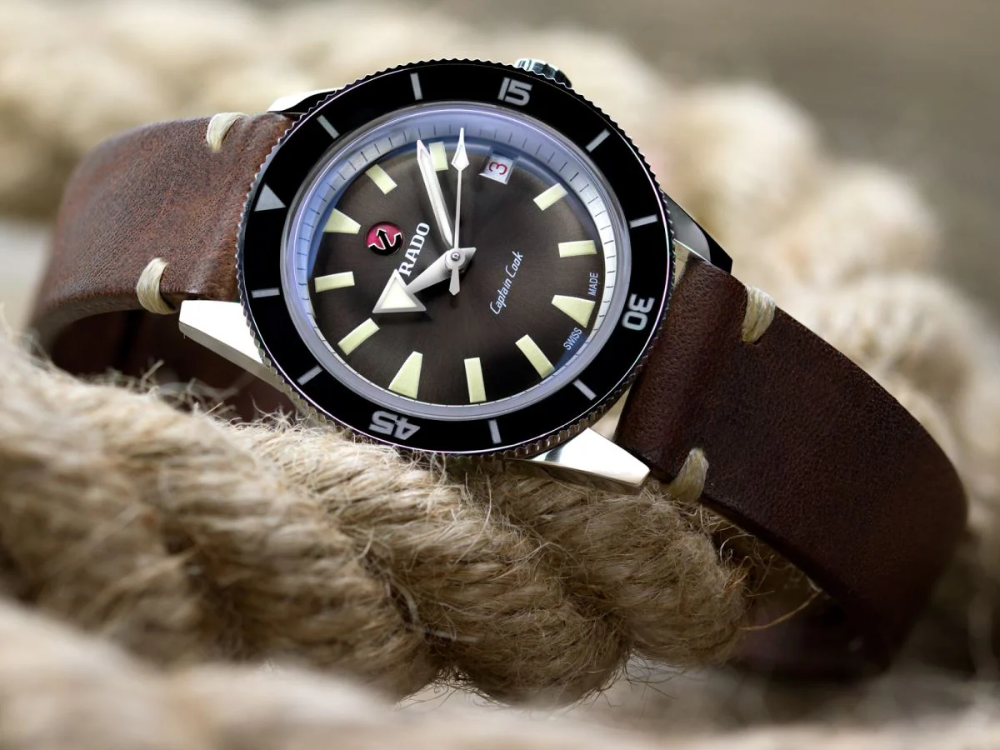

DESCRIPTION: Rado is a globally recognized Swiss watch brand known for its innovative design, high-quality craftsmanship, and use of premium materials. Founded in 1917, Rado has set itself apart by pioneering the use of scratch-resistant ceramics, sapphire crystal, and high-tech materials in watchmaking. With iconic collections like the Rado Centrix, Hyper-Chrome, and True, the brand offers a perfect blend of elegance, durability, and modern aesthetics. Rado watches are celebrated for their sleek and minimalist designs, making them a preferred choice for those who appreciate both style and innovation. Owning a Rado is a testament to timeless sophistication and cutting-edge technology.